

**University Institute of Information Technology,**

**PMAS-Arid Agriculture University,**

**Rawalpindi Pakistan**

**Trading Track**

***By***

**Muhammad Bilal 19-ARID-824**

**Haris Mehboob 19-ARID-802**

***Supervisor*Mr. Suleman Khurram**

**Chapter 2: Problem Definition**

# Problem Statement

For starters, there is not a single existing website on the internet that uses AI techniques to give suitable suggestions by gathering and merging historical and current data. We commonly see different websites that excel in either giving news or fundamental and technical analysis but a platform that lets you take note of all the important aspects in one place is yet to be seen. Users commonly take notes for fundamental analysis and technical analysis from different websites and then proceed to take notes of historical and current data from different websites and it causes quite a hassle. Since most of the users are not tech-savvy, they find it difficult to take notes from different websites and put them together. It is quite a hassle when you have to switch between tabs and copy-paste the data into an excel sheet. Also, it is very time-consuming when you have to keep doing this process again and again. Moreover, present trading systems don't provide data on the sentiments of traders for finding the trend to which big shark traders are going to shift.

# Deliverables and Development Requirements

The following are the deliverables of our project with their respective submission time:

|  |  |
| --- | --- |
| **Proposal** | **27th Oct 2022** |
| **Design** | **2nd Jan 2023** |
| **Application** | **1st May 2023** |
| **Documentation** | **15 th May 2023** |

**Table 2.1: Deliverables Table**

**Development Requirement for our project includes:**

* A stable Internet Connection.
* Code editor.
* Web browser.
* Installed Libraries and packages.
* Subscription of APIs used
* Google Collab for Training models

1. **Development Requirement**
   * + Hardware Requirement: No hardware is required for the project. Project is web based and only software will be required (browser) where project can run smoothly.

# Current System

There are certain existing systems that either excel in giving news or perform analysis. These systems lack major components that are required by traders. Following are some systems available on internet:

* **Trading View [1]** provides a platform for users to learn new trading strategies from other traders and then implement them in their own trades. It also provides an easy-to-use interface that allows users to build custom indicators using provided templates and then add them to their accounts quickly without having to know any programming languages or coding skills whatsoever!

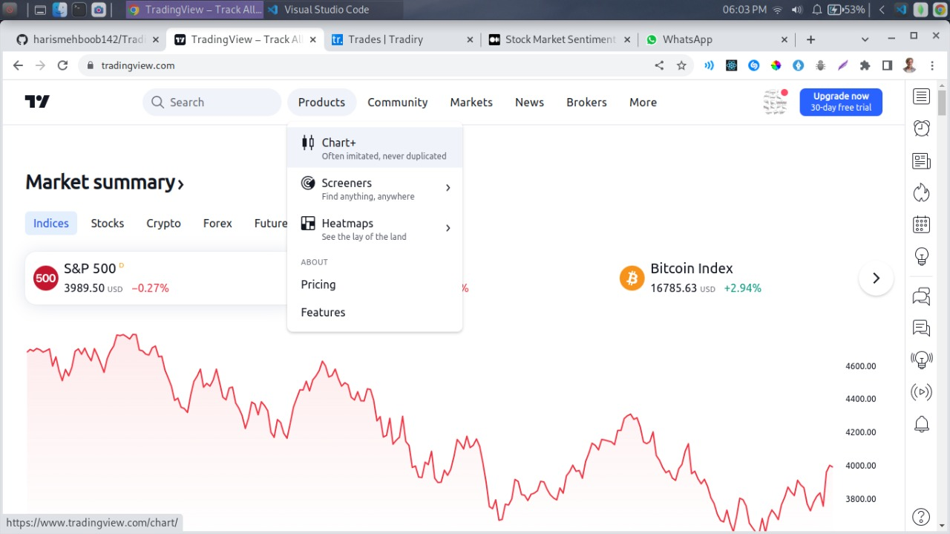

**Figure 2.1: Trading View**

* **Forex Factory [2]** is a website that provides news about forex market. News include the latest trending topics and important events happening in the forex market. The site also provides information about how to trade forex, how to choose a broker, etc.

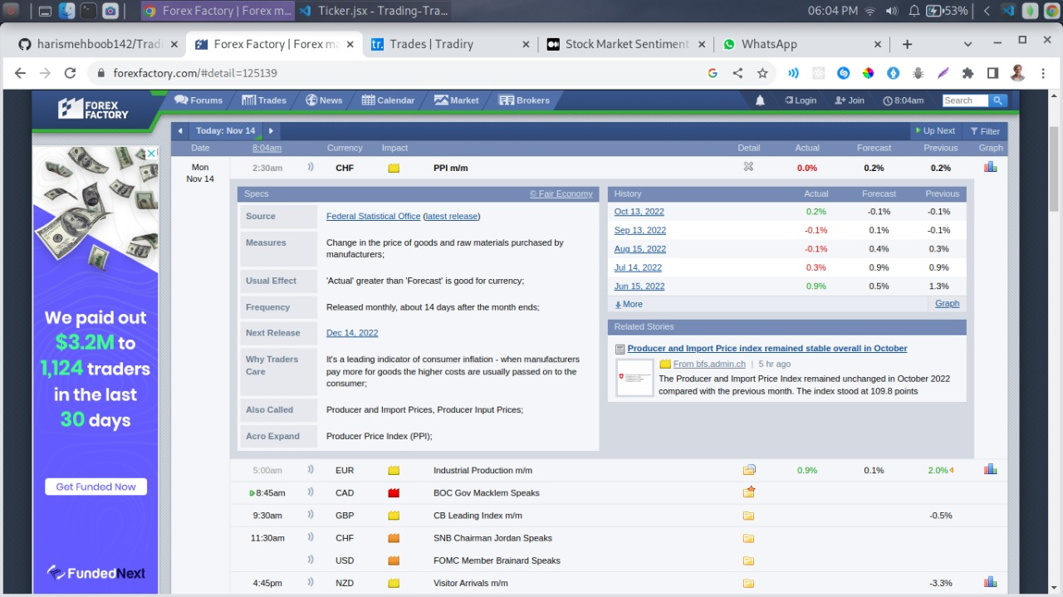

**Figure 2.2: Forex Factory**